Salary

**Dataset**

Data-drivers have chosen the “*Salary”* dataset to work with for the final group project. For the initial exploration of the dataset, we’ll use Python to find some interesting facts about the data.

**Case Identification**:

* **Case Number**: Unique identifier for each case.
* **Case Status**: Current state of the case (approved, denied, withdrawn).
* **Case Received Date & Decision Date**: Timelines for when cases were filed and when decisions were made.

**Employer Information**:

* **Employer Name**: The name of the organization hiring the applicant.

**Visa and Employment Type**:

* **Visa Class**: Type of visa applicable to the job.
* **Full-Time Position**: Full-time or Part-time.
* **Job Title Subgroup**: Further categorization of the job title for detailed analysis.

**Job Details**:

* **Job Title**: Position being offered.
* **Work City & State**: Geographical location of the job.
* **Work Postal Code**: Specific postal area for the job.

The dataset provides data about employment cases related to labor certifications and visa applications. It features unique identifiers for each case, along with their current statuses and the dates they were received and decided. The data provide details like the employer's name, which identifies the hiring companies, as well as wage information that compares the proposed prevailing wages to the actual wages paid, allowing for insights into any discrepancies. The dataset also includes job titles, locations (city and state), and postal codes, giving context about where the opportunities are. Additionally, it outlines educational and experience requirements, detailing the necessary education levels and whether prior experience is needed, with experience specified in months. Demographic data, such as the applicant's country of citizenship, can influence visa eligibility. The dataset further classifies jobs using standard codes and indicates the type of visa associated with each position, noting whether the jobs are full-time or part-time. Overall, this dataset is a valuable resource for examining employment trends, wage differences, and the connection between immigration and job opportunities.

***5 Fun Facts***

1. ***Number of unique job titles in the Dataset***

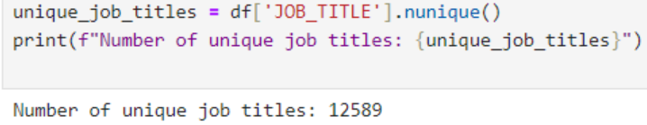

1. ***State with the highest average paid wage***

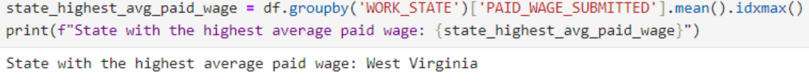

1. ***Most common visa***

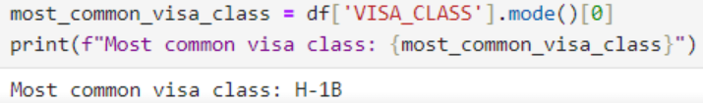

1. ***Top emplyers by number of cases***

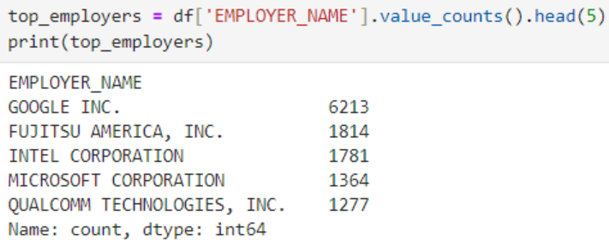

1. ***The distribution of the number of applicants is distributed***

